|  |  |  |
| --- | --- | --- |
|  | **Weekly Team Task Report** | **#14** |

|  |  |  |  |  |  |  |  |  |
| --- | --- | --- | --- | --- | --- | --- | --- | --- |
| Team: GeoLearn | | | | | | **Date: 4/28/2020** | | |
| **Project Title: Improving elementary education with custom online enironmental science lectures** | | | | | | | | |
|  | **Samuel Prassse**  Present  On-time |  | **Kaitlyn Grubb**  Present  On-time |  | **Tyler Pehringer**  Present  On-time | |  | **Joshus Tenakhongva**  Present  On-time |

### Recent Meetings:

* General Team Meeting
* Sponsor Meeting (Thursday)
* Sponsor Meeting (Monday)

### TASKS COMPLETED since last meeting:

|  |  |  |
| --- | --- | --- |
| **Task Title: Peer Eval #4** | **Who (%): Team (100%)** | **Rough Due Date: 4/24** |
| **Description: Review and send off an Excel sheet containing the scores and description of our team ratings over the past few weeks. Due at capstone presentaiton time.** | | |

|  |  |  |
| --- | --- | --- |
| **Task Title: Capstone Final Presentations** | **Who (%): Team (100%)** | **Rough Due Date: 4/23** |
| **Description: Capstone final presentations are due by end of business on Thursday April 23, the night before the regularly scheduled Capstone. The UGRADs folks promise there will be a way to upload them to the UGRAD site, which will be required.  We will also upload them with BBlearn, for easy collection and access by team mentors for grading.** | | |

### This week’s Tasks: Work plan for coming week

|  |  |  |
| --- | --- | --- |
| **Task Title: Peer Eval #5** | **Who (%): Team (100%)** | **Rough Due Date: 5/1** |
| **Description: Review and send off an Excel sheet containing the scores and description of our team ratings over the past few weeks. Due at end of semester.** | | |

|  |  |  |
| --- | --- | --- |
| **Task Title: Final “As-Built”** | **Who (%): Team (100%)** | **Rough Due Date: 5/1** |
| **Description: The final report summarizes "the story" of the project into a single coherent narrative. If someone had time to read just one document to understand everything about this project, starting from**  **motivations and vision, summarizing the development process, and describing the resulting product,**  **this would be the document to read. Much of the material to be included in the report can and**  **should be shamelessly re-used from previous document products you've produced...with appropriate**  **condensing, seaming together and cleaning up, of course.** | | |

### Upcoming Tasks: Planning

|  |  |  |
| --- | --- | --- |
| **Task Title: Final Project Delivery** | **Who (%): Team (100%)** | **Rough Due Date: 5/7** |
| **Description: The aim of formal product delivery is to make sure that the team has done its due diligence in**  **installing the product to the client’s satisfaction, and educating the client on how to operate the**  **product. It consists of two parts: The product User Manual, and the Product Delivery Checkoff Sheet.** | | |

|  |  |  |
| --- | --- | --- |
| **Task Title: Team reflection document** | **Who (%): Team (100%)** | **Rough Due Date: 5/1** |
| **Description: At the end of a project, it’s useful to go back and reflect on how the project went, how the team functioned, how effectively you used tools, and so on. This worksheet is designed to guide you in this process, and capture the outcomes.** | | |

### Other Problems / Other Issues:

* <

**Schedule:**

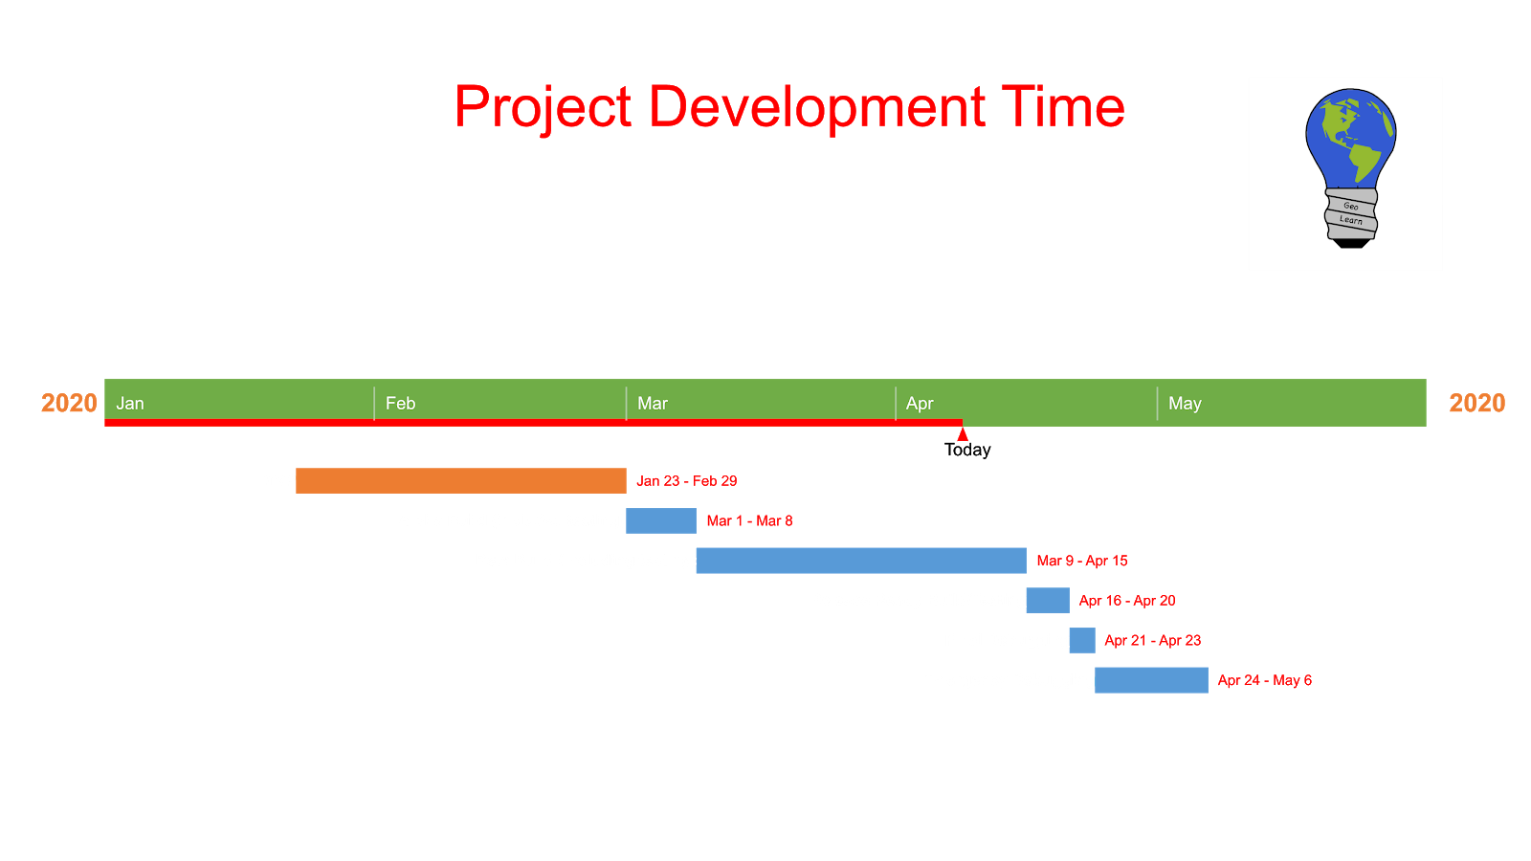

**Github:**

